Aim: Design structure for Operating System.

Description:

The Operating System Selection System is designed to allow users to choose their preferred operating system from a set of options, including Windows, Linux, and MacOS. The design follows object-oriented principles, employing an interface called OperatingSystem with concrete implementations for each supported operating system.

Code:

1. OperatingSystem.java

public interface OperatingSystem {
// Method to print the chosen operating system
void printChosenOperatingSystem();
}

2. LinuxOperatingSystem.java

// LinuxOperatingSystem.java
public class LinuxOperatingSystem implements OperatingSystem {

@Override
public void printChosenOperatingSystem() {
System.out.println("Chosen operating system: Linux");
}
}

3. WindowsOperatingSystem.java

// WindowsOperatingSystem.java
public class WindowsOperatingSystem implements OperatingSystem {

@Override
public void printChosenOperatingSystem() {
System.out.println("Chosen operating system: Windows");
}
}

4. MacOSOperatingSystem.java

// MacOSOperatingSystem.java
public class MacOSOperatingSystem implements OperatingSystem {

@Override
public void printChosenOperatingSystem() {
System.out.println("Chosen operating system: MacOS");
}
}

5. Main.java
import java.util.Scanner;

public class Main {
public static void main(String[] args) {
Scanner scanner = new Scanner(System.in);

System.out.println("Choose an operating system (Windows, Linux, MacOS): ");
String osChoice = scanner.next().toLowerCase();

OperatingSystem operatingSystem;

switch (osChoice) {
case "windows":
operatingSystem = new WindowsOperatingSystem();
break;
case "linux":
operatingSystem = new LinuxOperatingSystem();
break;
case "macos":
operatingSystem = new MacOSOperatingSystem();
break;
default:
System.out.println("Invalid operating system choice. Exiting.");
return;
}

operatingSystem.printChosenOperatingSystem();
}
}

Output:
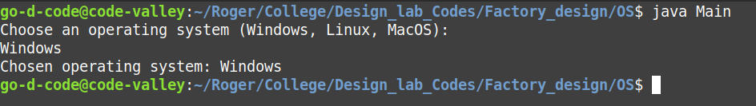
Class Diagram:
